

**Events organised by IEEE DITU Student Chapter (2016-17):**

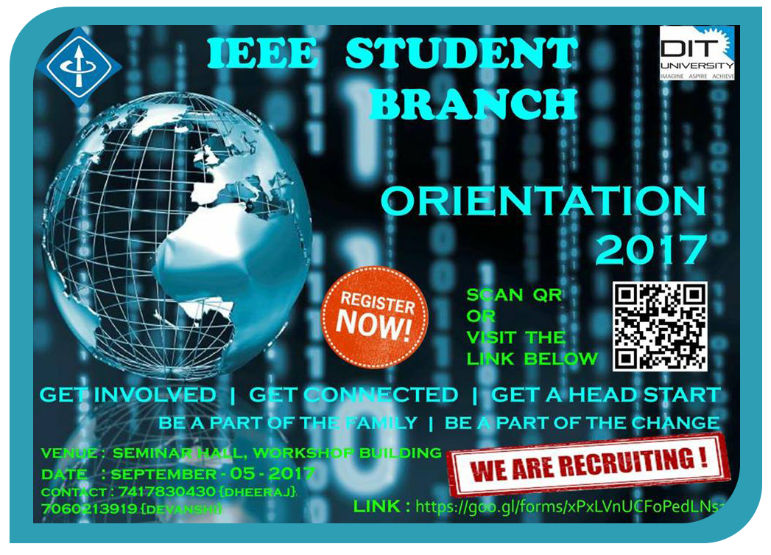

25 & 26 August,17-

Workshop on Cybersecurity

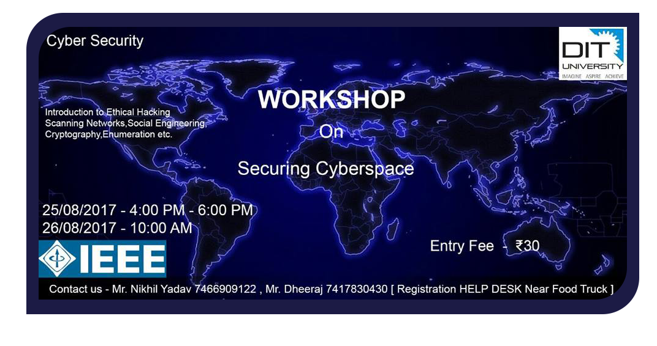

15April to 1st June,17-

IEEEmadC (Mobile Applications Development Contest) is an international contest organized by IEEE for all students across the globe.

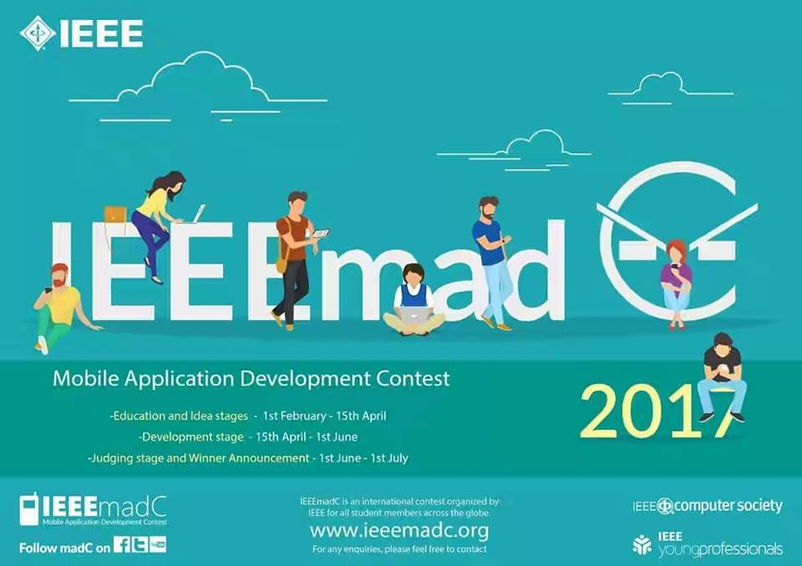

2 to 5 April,17-

Workshop on “Web Development(WebD)”

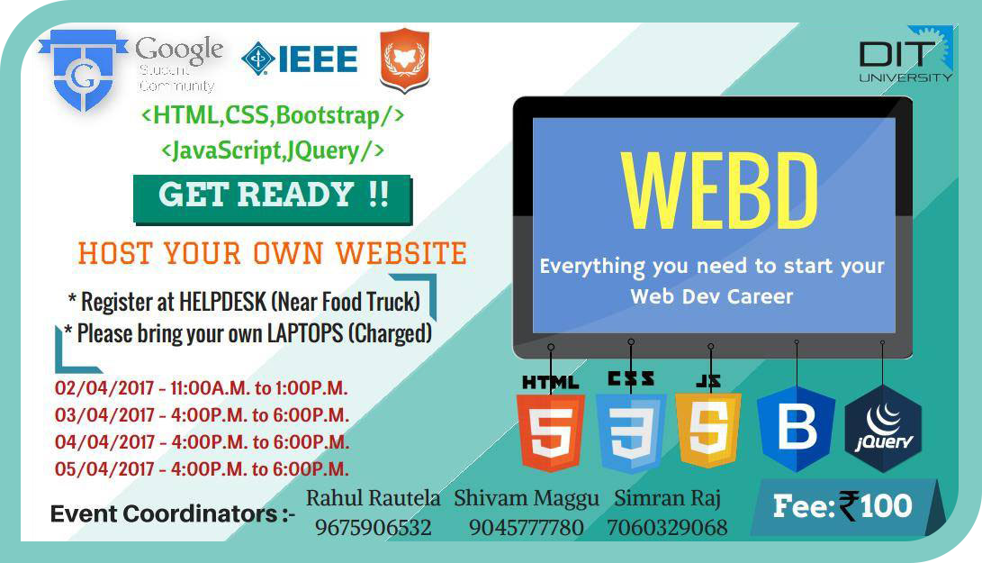

 With collaboration of Google Student Community, IEEE Student Branch, and Firefox Student Club

2 to 5 Feb,17-

Workshop on ‘PCB designing’

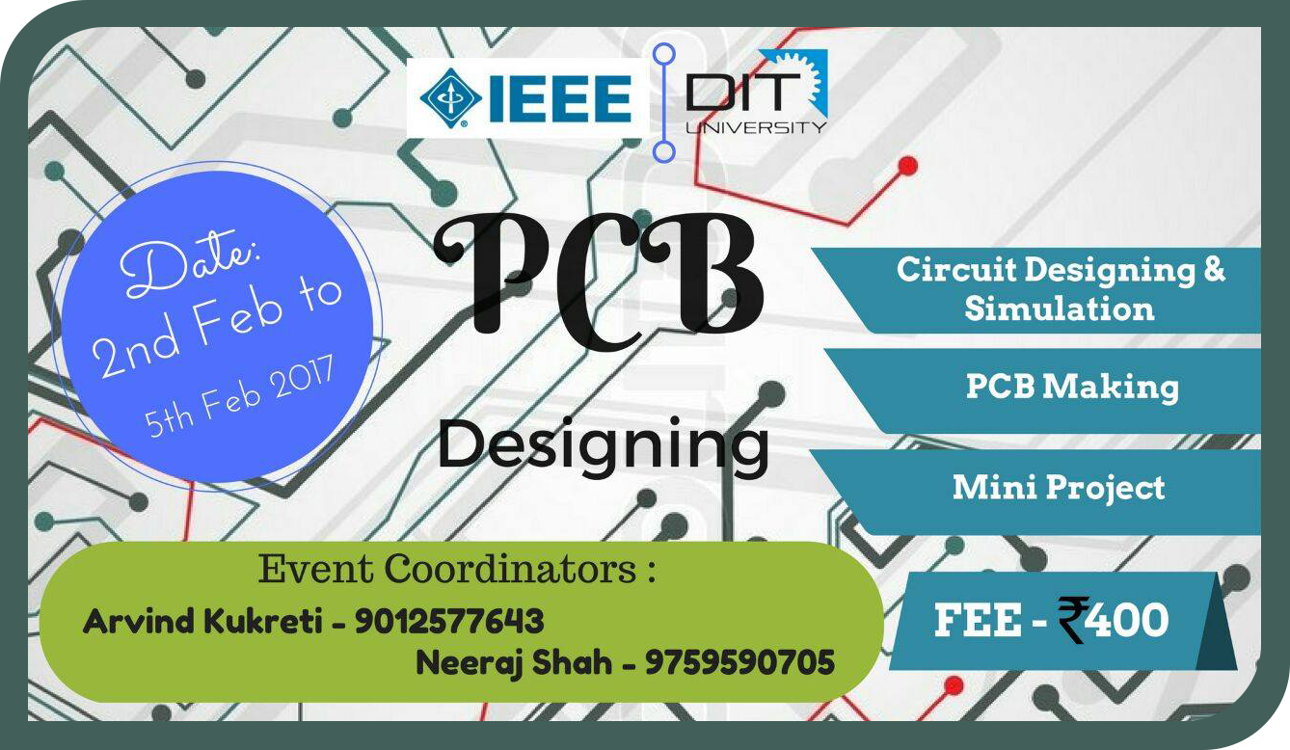

31 Jan,17-

The IEEE Students' Chapter, DITU organised a workshop on the Fundamentals of Electronics. They got a taste of what electronic circuits are all about, as well as hands-on experience dealing with them. They covered some basic concepts, circuit designing and lots of mini fun projects as part of this workshop.

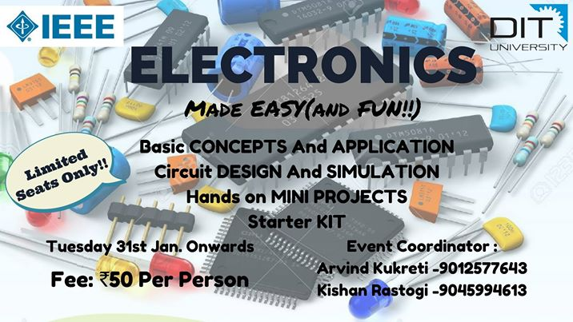

13 Nov, 16: -

Seminar on “Web Development”.

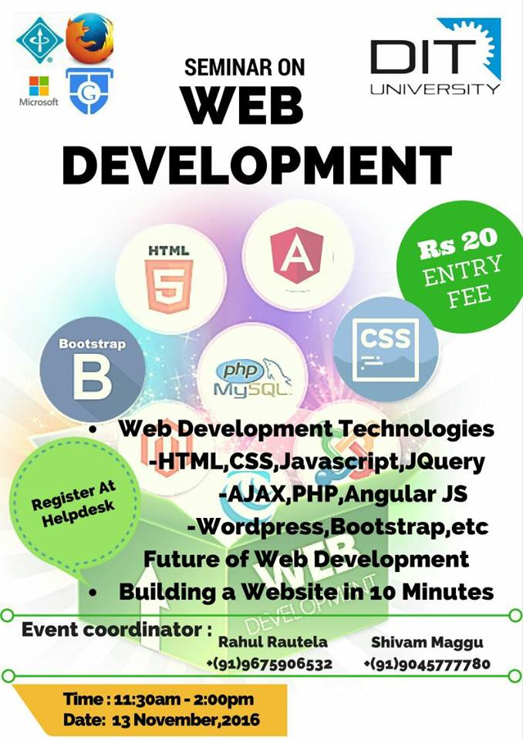

20 to 22 Oct,16: -

Organised Technical Events like Line Follower, Robo Soccer under Youthopia’16 Technical and Cultural fest held at DIT University.

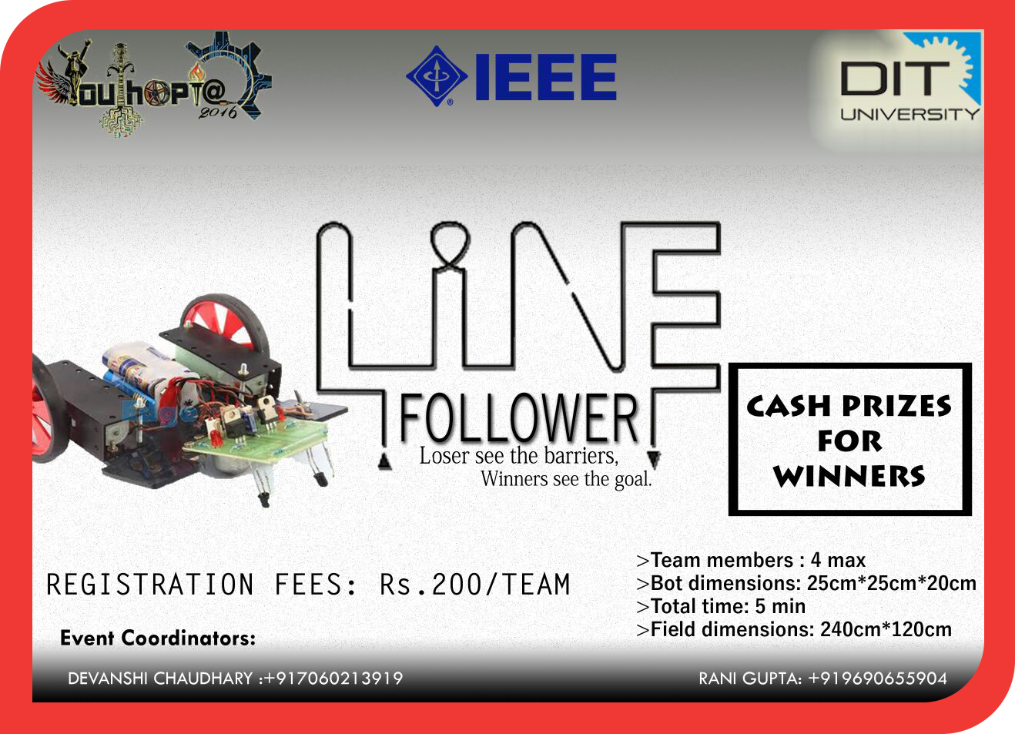

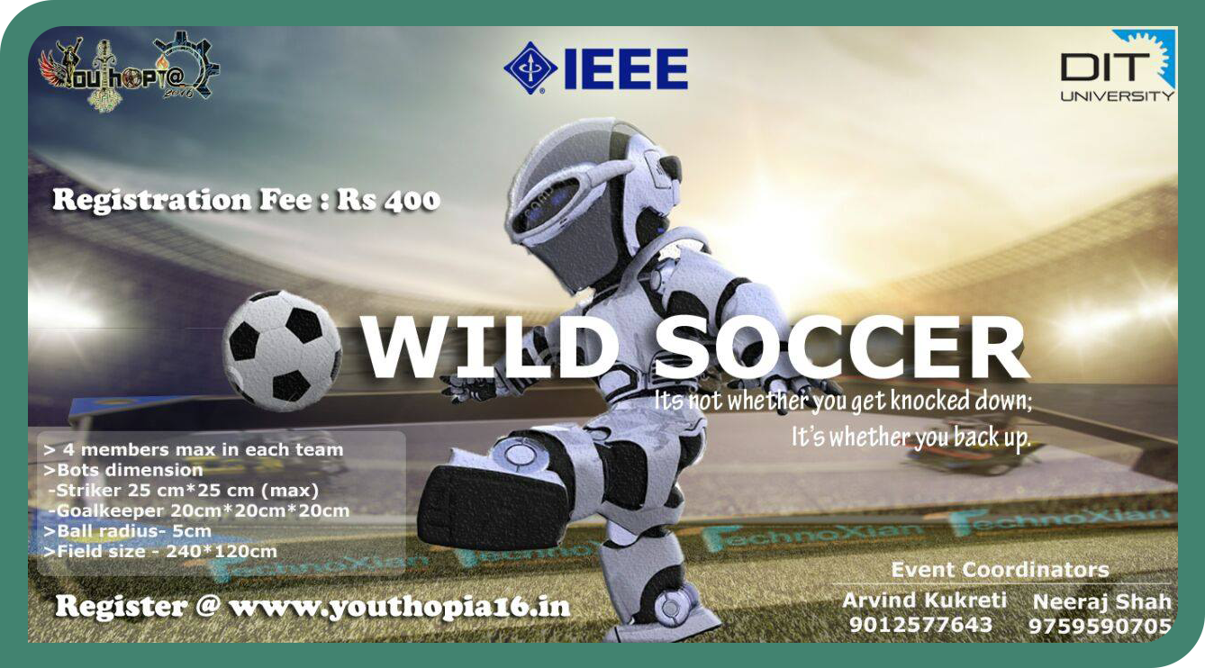



8 Oct,16: -

Seminar on wireless robots

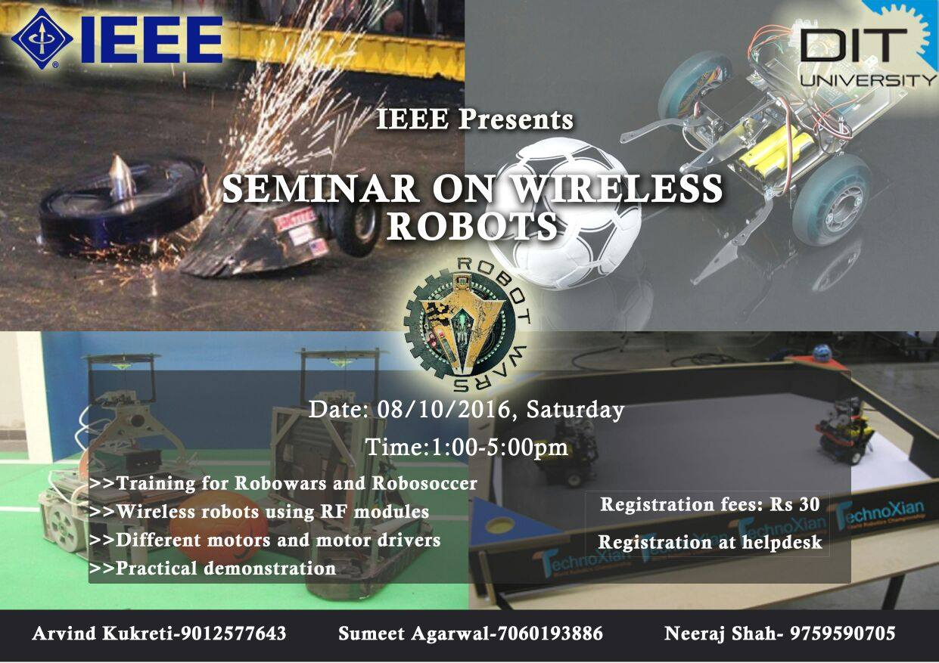

19th Sept,16: -

Seminar on Hologram

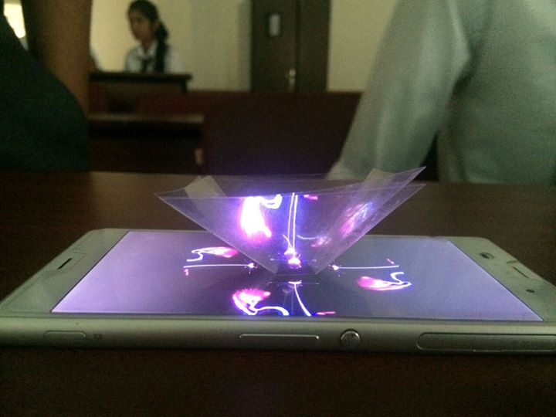

25 to 29 Aug,16: -

Workshop on “Introduction to Embedded Systems With the Arduino”

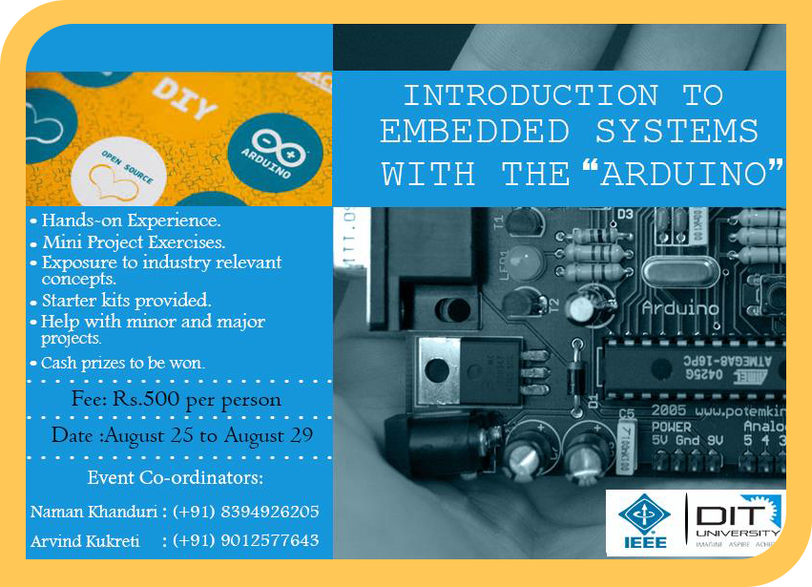

15 March,16: -

Workshop on” Image processing and computer vision using OpenCV”.

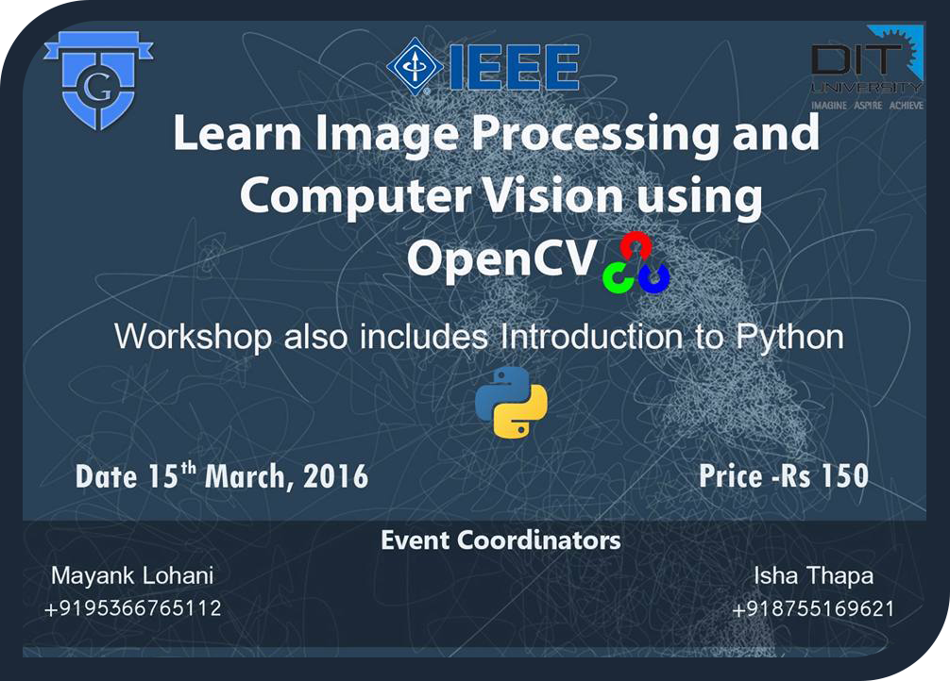

4 Feb,16: -

Workshop on PCB Designing

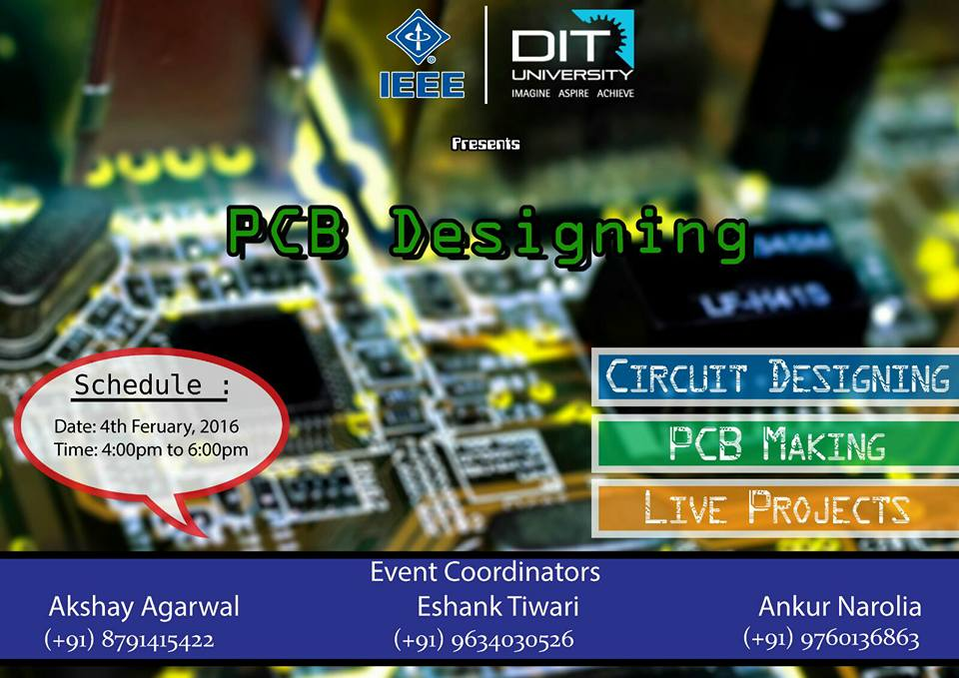

27 to 30 Jan,16: -

Conducted Competitive Coding Event “Big-O”

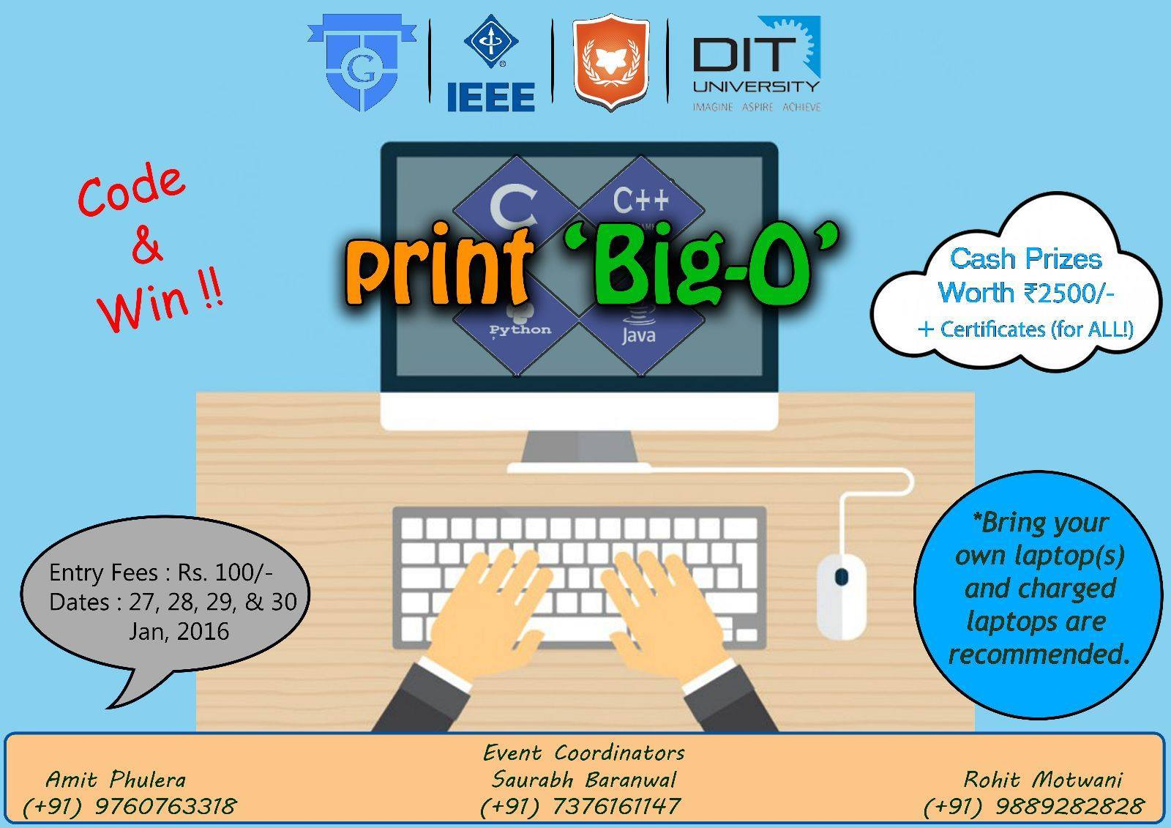

**Events to be organised by IEEE:**

IEEE Day celebrates the first time in history, when engineers worldwide and IEEE members gathered to share their technical ideas in 1884. IEEE Day 2017 is the 8th edition of the same and will be celebrated on 5tj October 2017.

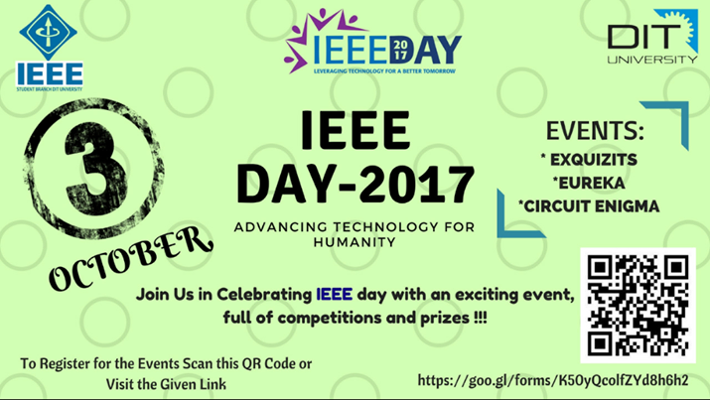

**EUREKA:**

So this IEEE Day , come up with your Best ideas,those eureka moments that turn the world upside down As this October 5th 2k17 IEEE brings to you an opportunity to share your Ideas with us and a chance to win exciting cash prizes.

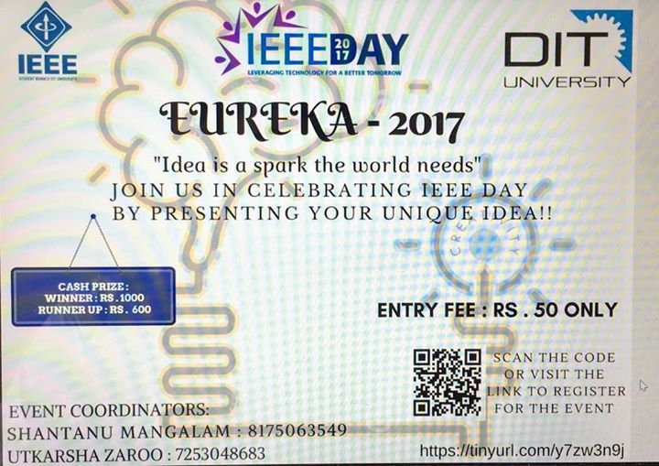

**EXQUIZITS:**

 IEEE DITU brings you exquizits as a part of IEEE day. A quiz that is giving genuises a run for their money.  
First round will include,12th basic and few logical questions.(Total 30)  
Second will include technical,programming,audio and visual questions.(Total 20)

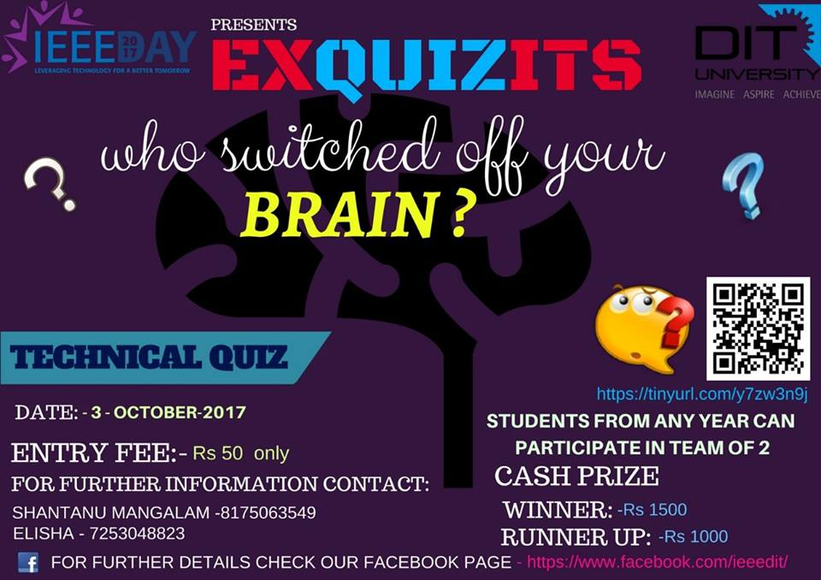

**IEEE Extreme:**

IEEE Xtreme is a global challenge in which teams of IEEE Student members – advised and proctored by an IEEE member, and often supported by an IEEE Student Branch – compete in a 24-hour time span against each other to solve a set of programming problems.  
Teams of up to three collegiate students who are current IEEE student members.

